Software Setup Procedure

We need the following software to be setup before starting development:

* Java 17+ (JavaFX21 requires v17+)
* VS Code (geared towards java development)
* Git
* MySQl

### JDK24: (Skip if Java17+ already installed)

Goto: [Java Downloads | Oracle](https://www.oracle.com/java/technologies/downloads/)

Download the x64 MSI Installer:

Start Installation process and follow the screenshots:

Check if Java is properly installed:

Add Environment Variables:

Copy the path of your java installation like: C:\Program Files\Java\jdk-24

Go to Environment Variables:

If you don’t have a JAVA_HOME variable inside the System Variables section, click New

Click OK and restart the system after closing all the popups.

### VS CODE:

Install VS Code by following the screenshots:

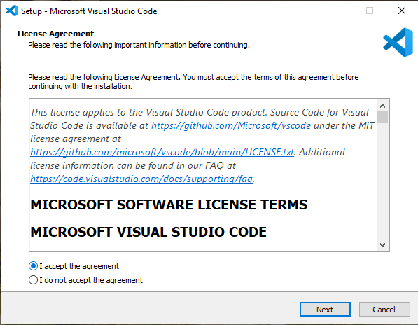

Once VS Code is successfully installed, proceed with installing the ‘Extension Pack for Java’ extension for Java development in VS Code:

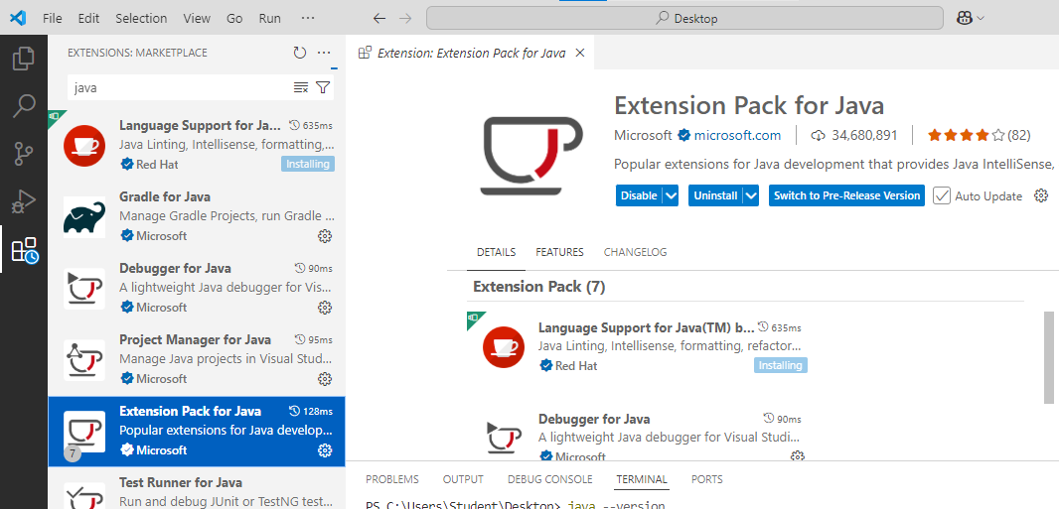

This will install all the extensions necessary for java development in VS Code.

### Git Setup:

If you don’t have a github account, create a github account by going to: <https://www.github.com> and then clicking on ‘Sign Up’

After creating account with Github, go to: <https://github.com/git-for-windows/git/releases/download/v2.49.0.windows.1/Git-2.49.0-64-bit.exe>

This will download the proper git version.

Then follow the screenshots:

### MySQL Installation:

Go to: <https://dev.mysql.com/downloads/installer/>

Download the full version (300+ MB)

Then follow the screenshots after double clicking the ‘*mysql-installer-community.exe’* file:

Give root password as ‘root’

Click ADD USER and give your first name in all smallcaps as user and password as ‘root’

